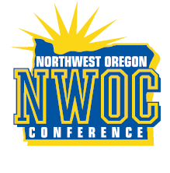
NORTHWEST OREGON CONFERENCE
Admission Prices

5A PLAY-IN CONTESTS

ADULTS…………………….………………..$6.00

STUDENTS..………………….……..……….$4.00

These passes accepted only:
Coaches Gold Cards, OSAA VIP, and Media Passes

Milwaukie Parkrose Rex Putnam Sandy
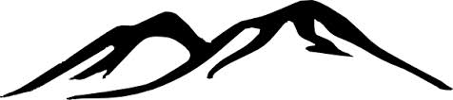
LaSalle St. Helens
Hillsboro Wilsonville

OSAA
5a District 1

